Supplementary File 2. GTEx database gene expression query steps.
- Go to GTEx database website (https://gtexportal.org/).
- QTLs & Browsers > eQTL Calculator
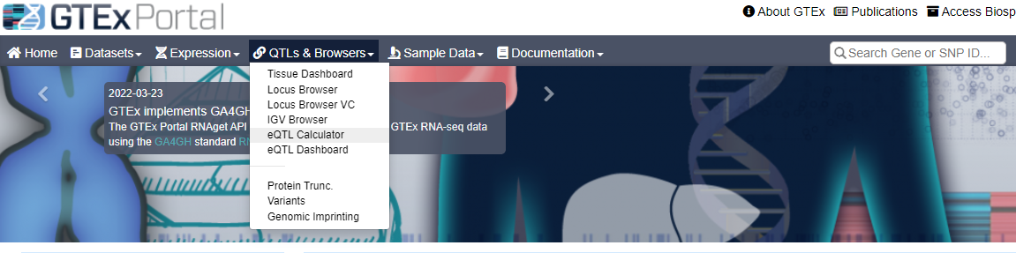
- Enter Variant ID, Gene ID, Tissue name, then press “Calculate Your Own”.
Example:
rs28481460,ABHD2,Whole_Blood
rs28481460,ABHD2,Muscle_Skeletal
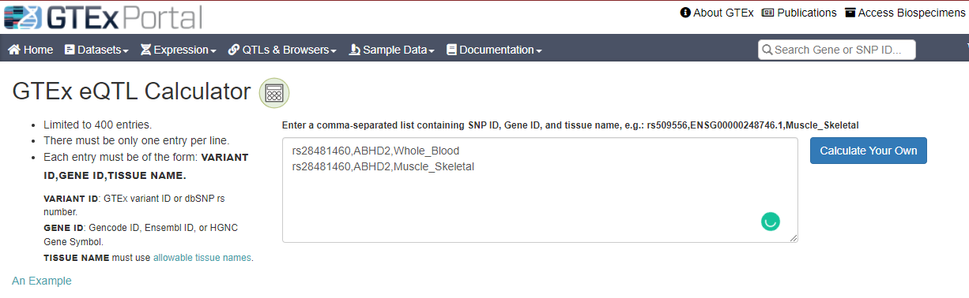
- Obtain analysis results and eQTL violin plot.
